|  |  |  |  |  |  |  |  |  |
| --- | --- | --- | --- | --- | --- | --- | --- | --- |
|  | MAE | | MSE | | RMSE | | Score | |
|  | Train | Test | Train | Test | Train | Test | Train | Test |
| 1 | 0.4404 | 0.9345 | 0.3784 | 1.3697 | 0.5898 | 1.1456 | 0.8042 | 0.2911 |
| 2 | 0.4904 | 0.7917 | 0.4128 | 0.9263 | 0.6393 | 0.9536 | 0.8012 | 0.5206 |
| 3 | 0.6722 | 0.8670 | 0.7584 | 1.0730 | 0.8665 | 1.0281 | 0.6347 | 0.4447 |
| 4 | 0.6880 | 0.7687 | 0.7189 | 0.8483 | 0.8479 | 0.9210 | 0.6537 | 0.5610 |
| 5 | 0.5667 | 0.7696 | 0.5250 | 0.8214 | 0.7230 | 0.9010 | 0.7471 | 0.5749 |

Comparacao de modelos: <https://people.duke.edu/~rnau/compare.htm>

[5]

0.5667

0.7696

0.5250

0.8214

0.7230

0.9010

0.7471

0.5749

1: Hidden Layer = 3-3 ; activation = relu ; solver = lbfgs ; batch_size = 2 ; max_iter = 500

2: Hidden Layer = 3-3 ; activation = relu ; solver = adam ; batch_size = 2 ; max_iter = 500

3: Hidden Layer = 2 ; activation = tanh ; solver = adam ; batch_size = auto ; max_iter = 1000, alpha = 0.0001

4: Hidden Layer = 1 ; activation = tanh ; solver = adam ; batch_size = auto ; max_iter = 1000, alpha = 0.0001

5- Hidden Layer = 2 ; activation = relu ; solver = adam ; batch_size = auto ; max_iter = 1000, alpha = 0.01

MPL treino com Score = 0.8422 (Valor Máximo)

MPL teste com Score = 0.7401(Valor máximo)

MPL treino com Score = 0.9184 (Valor Máximo)

MPL teste com Score = 0.6778 (Valor máximo)

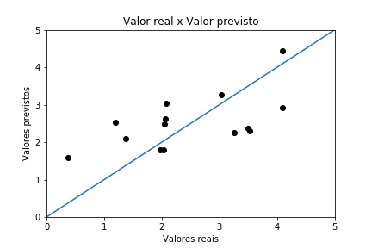

Grafico obtido para a configuração 5

Top 10 Testes:

x1 = relu, x2 = sgd, x3 = (2, 1), x4 = 0.0001, x5 = 8

**x1 = relu, x2 = lbfgs, x3 = (2, 1, 2), x4 = 0.0001, x5 = 5**

x1 = relu, x2 = lbfgs, x3 = (2, 2, 1, 1), x4 = 0.0001, x5 = 8

x1 = relu, x2 = lbfgs, x3 = (2, 1, 2, 1, 2), x4 = 0.0001, x5 = 2

x1 = relu, x2 = lbfgs, x3 = (2, 1, 1, 1, 2), x4 = 0.0001, x5 = 2

x1 = relu, x2 = lbfgs, x3 = (2, 1), x4 = 0.0001, x5 = 2

**x1 = relu, x2 = adam, x3 = (2,), x4 = 0.001, x5 = 10**

x1 = relu, x2 = adam, x3 = (2, 1, 2), x4 = 0.0001, x5 = 8

x1 = relu, x2 = adam, x3 = (2, 2, 2, 2), x4 = 0.001, x5 = 2

x1 = relu, x2 = adam, x3 = (2,), x4 = 0.001, x5 = 2